CLASSROOM NEWSLETTER
Term 1 – Weeks 8 & 9

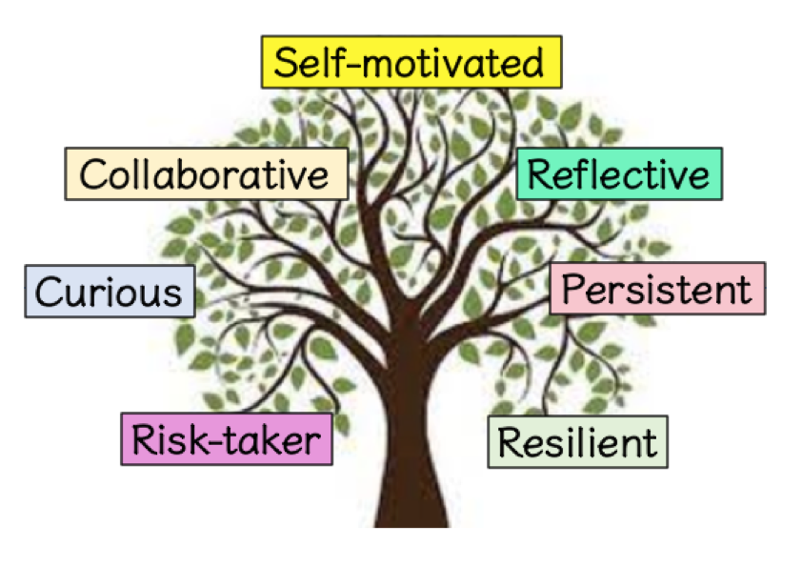
Dear Grade Prep Parents/ Guardians,

Please find our email addresses if you wish to contact us:
Doreen Micallef (Prep M) – dmicallef@canahillside.catholic.edu.au
Alexandra O’Shea (Prep O) – aoshea@canahillside.catholic.edu.au

Over the next two weeks we will be learning about the following:

SCHOOL FOCUS/WELLBEING:
Cana Characteristics of an Effective Learner:
- Being resilient

RELIGIOUS EDUCATION:
Our overarching theme for Religious Education in term 1 is Belonging.
Unit topic – Holy Week
- Sequence and retell a story from Holy Week.
- Make connections between an event in Holy Week and to my life.
- Identify one way I am going to be more like Jesus towards others through the actions of welcoming, sharing and praying.
MATHEMATICS:
Number
- Read number words 0-10.
- Match number words with numerals and quantities 0-10.
Measurement

- Use the terms yesterday, today and tomorrow to name events that occur.
- Compare events and identify which takes a shorter or longer amount of time.
ENGLISH:
Reading and Viewing
- Read aloud simple texts in shared reading.
- Begin to develop concepts about print. E.g using meaning from pictures to predict words.
- Recognise some letters of the alphabet and become aware of the relationship between sounds and letters.
Writing:
- Begin to form upper- and lower-case letters.
- Be exposed to beginning sounds in words.
- Begin to identify features of a sentence e.g. full stops, capital letters.
Spelling:
- Revision of words of the week; cat, ant, tin, tap.

Listening and Speaking
- Participate and contribute to class discussions by asking and responding to questions.
- Take turns in discussions.

INQUIRY UNIT:
Self-Motivated
Resilient
Persistent
Curious
Collaborative
Risk Taker
Reflective

Unit topic – I am a Learner
Inquiry question – What is a learner?
- Makes connections between themselves and the 7 characteristics of an effective learner at Cana.

